Exercise 3: Azure Blueprints

Scenario

Learning how to create and assign blueprints enables the definition of common patterns to develop reusable and rapidly deployable configurations based on Resource Manager templates, policy, security, and more. In this tutorial, you learn to use Azure Blueprints to do some of the common tasks related to creating, publishing, and assigning a blueprint within your organization, such as:

* 1. Create a new blueprint and add various supported artifacts
  2. Make changes to an existing blueprint still in Draft
  3. Mark a blueprint as ready to assign with Published
  4. Assign a blueprint to an existing subscription
  5. Check the status and progress of an assigned blueprint
  6. Remove a blueprint that has been assigned to a subscription

Create a blueprint

The first step in defining a standard pattern for compliance is to compose a blueprint from the available resources.

1. Click on **All services** and searching for and selecting **Policy** in the left pane. On the Policy page, click on **Blueprints**.
   1. Select **Blueprint Definitions** from the page on the left and click the **+ Create Blueprint** button at the top of the page.
   2. Alternately, click on **Create** from the **Getting started** page to go straight to creating a blueprint.

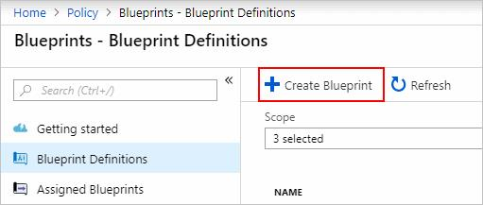

* 1. Select the **NIST** blueprint
  2. Name the Blueprint as you wish. In the **Definition Location** box, click the ellipsis on the right, select the management group root and click **Select**.
  3. Verify the information is correct (the **Blueprint Name** and **Definition Location** fields can't be changed later) and click **Next : Artifacts** at the bottom of the page or the **Artifacts** tab at the top of the page.
  4. Click **Save Draft** at the bottom of the page.

Publish a blueprint

Now that all the planned artifacts have been added to the blueprint, it's time to publish it. Publishing makes it available to be assigned to a subscription.

* 1. Select **Blueprint Definitions** from the page on the left.
  2. In the list of blueprints, right-click on the one you previously created and select **Publish Blueprint**.
  3. Enter a Version
  4. Click **Publish** at the bottom of the page.

Assign a blueprint

Once a blueprint has been published, it can be assigned to a subscription. Assign the blueprint you created to one of the subscriptions in your management group hierarchy.

* 1. Select **Blueprint Definitions** from the page on the left.
  2. In the list of blueprints, right-click on the one you previously created (or left-click on the ellipsis) and select **Assign Blueprint**.
  3. On the **Assign Blueprint** page, select the subscription(s) you want to deploy this blueprint to from the **Subscription** drop-down.

**Note:** An assignment is created for each subscription that is selected allowing changes to a single subscription assignment at a later time without forcing changes on the remainder of the selected subscriptions.

* 1. For **Assigned Name**, provide a unique name for this assignment.
  2. In **Location**, select a region for the managed identity to be created in. Azure Blueprint uses this managed identity to deploy all artifacts in the assigned blueprint.
  3. Leave the **Blueprint definition version** drop-down of **Published** versions on the 'v1' entry (default as the most recently Published version).
  4. For **Lock Assignment**, leave the default of **Don't Lock**.
  5. Use the system assigned managed ID
  6. Read the information box at the bottom of the page and then click **Assign**.

(scroll down and there is a lot of stuff to fill in)

Track deployment of a blueprint

When a blueprint has been assigned to one or more subscriptions, two things happen:

* + The blueprint is added to the Assigned Blueprints page per subscription assigned to
  + The process of deploying all the artifacts defined by the blueprint begins

Now that the blueprint has been assigned to a subscription, verify progress of the deployment.

* + Select Assigned Blueprints from the page on the left.
  + In the list of blueprints, right-click on the one you previously assigned and select View Assignment Details.

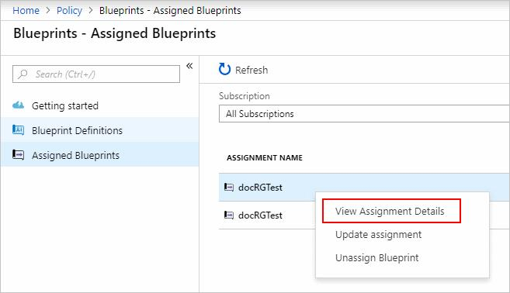

* + On the Deployment Details page, validate that all artifacts have been successfully deployed and that there have been no errors during the deployment. If errors occurred, see [troubleshooting blueprint](https://labondemand.com/content/lab51772/If%20errors%20occurred,%20see%20troubleshooting%20blueprint%20for%20steps%20to%20determine%20what%20went%20wrong.) for steps to determine what went wrong.

Unassign a blueprint

If no longer needed, remove a blueprint assignment from a subscription. The blueprint may have been replaced by a newer blueprint with updated patterns, policies, and designs. When a blueprint is removed, the artifacts assigned as part of that blueprint are left behind.

* 1. Select **Assigned Blueprints** from the page on the left.
  2. In the list of blueprints, select the blueprint that is to be unassigned and then click the Unassign Blueprint button at the top of the page.
  3. Read the confirmation message and then click **OK**.

Review [Understand the life-cycle of an Azure Blueprint](https://docs.microsoft.com/en-us/azure/governance/blueprints/concepts/lifecycle) as it is an essential aspect of Blueprints.

PreviousNext: Exercise 4: Resource Graph